Committee of Residents and Tenants

Terms of reference

Foundation Housing Ltd Committee of Residents and Tenants

Terms of Reference

Last updated: July 2021

Contents
1. Purpose 2
2. The role of the CORT 2
3. CORT Structure 3
4. How Foundation Housing and CORT communicate with each other 3
5. How CORT communicates with tenants and residents 4
6. Membership 5
7. Selection Criteria 6
8. Nominations 6
9. Biennial General Meeting 7
10. Member positions 7
11. Foundation Housing staff representatives 8
12. CORT Term 8
13. Meetings 8
14. Decision making 9
15. Participation payment 10
16. Training 10
17. Dispute resolution 10
18. Terms of Reference Review 11
19. Glossary 11

Purpose
The purpose of the Committee of Residents and Tenants (known as CORT) is to provide a forum for tenants and residents to provide feedback regarding the way in which Foundation Housing services are delivered to create safe, secure, sustainable and affordable housing.

The role of the CORT
- To provide a representative tenant and resident voice regarding the development and review of new and existing Foundation Housing policies, procedures and programs that impact residents and tenants.
- To provide a forum for Foundation Housing to provide feedback to tenants and residents about how their views are impacting the design and delivery of services.
- To be a conduit for tenants and residents to raise broad issues with the Foundation Housing Executive, including the ability to make representations to the TSEC (as appropriate) regarding matters of interest to tenants.
- To provide feedback to Foundation Housing as to how to engage and/or communicate issues of broad interest to tenants and residents
- To provide input into the development of an annual tenant engagement plan including the development of tenant and resident led initiatives particularly those which reduce social isolation through the provision of social activities.

CORT Structure
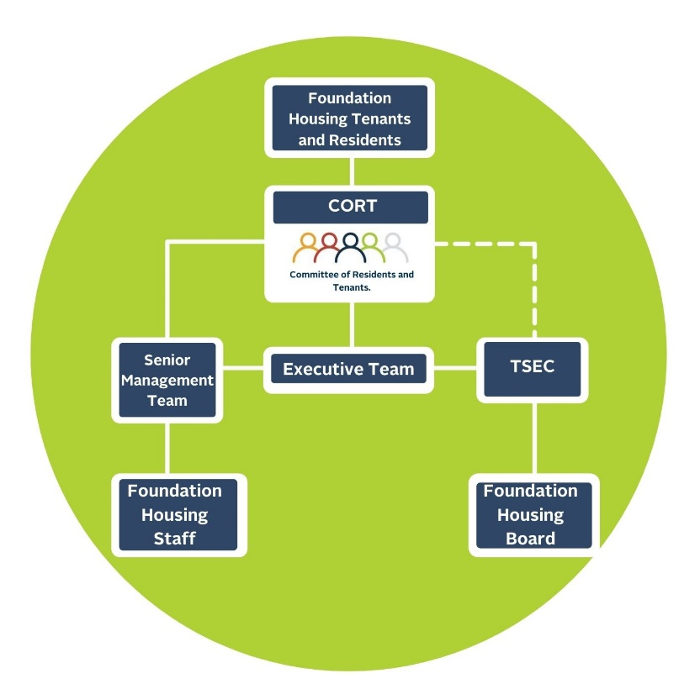

How Foundation Housing and CORT communicate with each other
  - Foundation Housing communicates with the CORT by:
    - Senior Management Team representation on the CORT.
    - Executive level staff member attendance at CORT meetings.
    - Community Services Team staff members co-designing the CORT agenda with the CORT Chairperson and/or Deputy Chairperson.
    - Both Foundation Housing and CORT contributing agenda items for each CORT meeting
    - Providing a staffing resource to help with the preparation of the agenda and drafting and distribution of key CORT decisions and actions to tenants, residents and Foundation Housing as described in section 11.1.
  - The CORT communicates with Foundation Housing by:
    - Standard agenda items in relation to CORT raised issues and feedback on Foundation Housing operational groups such as the Senior Management Team, Executive Team, OSH Committee and others as appropriate.
    - Opportunities to have a standing agenda item at the TSEC (Tenancy Services & Engagement Committee) and to discuss CORT issues directly at TSEC meetings, at TSEC’s discretion and invitation.

How CORT communicates with tenants and residents
The CORT can communicate with Foundation Housing tenants and residents in a variety of ways.
  - Tenants and residents can raise issues for CORT to consider by:
    - Nominating themselves for membership of the CORT in order to have direct input.
    - Attending and contributing to the CORT Biennial General Meeting, during which issues of broad interest can be raised and documented for consideration.
    - Completing the Biennial tenant survey, responses from which will be collated and provided to CORT to discuss any issues arising.
    - Involving themselves in tenant/resident engagement activities through which issues of broad concern will be captured and fed back to the CORT.
  - The CORT will communicate to tenants and residents via:
    - Foundation Housing newsletter, delivered in hardcopy by mail or digitally by email.
    - The CORT page on the Foundation Housing website.
    - The Foundation Housing and CORT Facebook group.
  - The CORT will also provide feedback to Foundation Housing as to how it can most effectively communicate with the broader tenant and resident cohort on key issues.
  - It is not expected that CORT members will identify issues of broad concern via direct contact with other tenants or residents (eg. neighbours) unless there are structured Foundation Housing led or tenant led engagement activities to facilitate this.

Membership
  - The Committee of Residents and Tenants (CORT) is a fixed/closed group of residents and tenants who are selected via a nomination process held once per year.
  - To be considered as a member of the Foundation Housing CORT, applicants must:
    - Be a Foundation Housing tenant, a registered household member, a lodge resident, or a carer (as defined by the Carers Recognition Act 2004) of a Foundation Housing tenant or resident.
    - Have completed a Foundation Housing CORT nomination form
    - Make a commitment to uphold the Foundation Housing CORT Code of Conduct
    - Be able to make the time commitment necessary for involvement for the biennial (ie. two year) term.
    - Be willing to participate in CORT training to be an effective tenant or resident representative
    - Be selected via either an election process (in the case of Executive CORT roles) or via a lottery system (as described below)
  - Membership will be promoted at new tenancy signups, via Housing and Lodging Coordinators and tenant and resident newsletters, social media, website and engagement activities.
  - The CORT nomination form will provide information about CORT and membership
  - The CORT will not exceed 20 members over any one 12-month period
  - Specific membership roles will be promoted to encourage nominations from across the full geographical and demographic mix of Foundation Housing’s social housing portfolio in order to ensure a representative mix of members. This will include:
    - First Nations tenants and residents
    - Tenants and residents with a lived experience of disability (physical cognitive, psychosocial etc.)
    - Tenants and residents who identify as LGBQTI+
    - Tenants and residents from culturally and linguistically diverse backgrounds
    - Lodging and share-house residents
    - Tenants and residents from regional areas

Selection Criteria
  - To be eligible for election, CORT members must demonstrate that they:
    - Fulfil the criteria for membership of the CORT per section 6.2 above.
    - Are able to participate effectively – either in person or remotely – in formal meeting settings.
    - Have respect for diverse viewpoints.
    - Can contribute ideas and suggestions to improve service delivery.
    - Can work constructively with other tenants, residents and Foundation Housing representatives.

Nominations
  - To enable maximum opportunity for participation, nominations can be made via completion of the nomination form at any time.
  - Nominations will be collated by the CORT secretary – a Foundation Housing staff member.
  - All eligible members can self-nominate.
  - Nominations will be considered for the CORT at the CORT Biennial General Meeting to be held in the last quarter of every second year, and when a vacancy arises on the CORT.
  - Nominations for executive and representative positions (e.g. Chairperson and Deputy Chairperson) are limited to one household member per position.
  - Tenants and residents nominating for executive and representative positions on the CORT will be asked to provide a short personal profile for the purposes of election.
  - Successful applicants for executive level and key representative roles should be comfortable with being visible in their community and available for public duties. General members can opt to be either visible in their community or not.
  - Unsuccessful nominated tenants and residents for executive and/or key representative positions will be eligible to be considered for the General Member lottery.
  - CORT vacancies will be advertised in the most appropriate medium/s available at the time, which may include the Foundation Housing tenant and resident newsletters, via email or during engagement activities.
  - Where there is more than one nomination for any position, a secret ballot will be held at the CORT Biennial General Meeting, or at the next scheduled CORT meeting
  - Foundation Housing reserves the right to make void any nomination for membership where there is a potential risk to the CORT being able to achieve its objectives and/or might pose a risk to other CORT members, Foundation Housing staff, or the nominated tenant or resident. The CORT will be advised wherever practicable when this occurs within the confines of confidentiality and privacy.

Biennial General Meeting
  - A Biennial General Meeting for the CORT will be held in the last quarter of every second year where the new committee will be announced.
  - The Biennial General Meeting can take place over two or more locations and will be made remotely accessible.
  - All tenants and residents will be invited to attend the meeting.
  - Tenants and residents will be encouraged to bring broad issues and ideas for the consideration of the CORT over its term of operation

Member positions
  - Chairperson
    - Roles: Facilitate CORT meetings; develop the agenda in consultation with Foundation Housing; manage relationships within CORT; time keeping; manage conversations to ensure a focus on agenda items and CORT business; resolve conflicts; attend TSEC as appropriate; ensure committee decisions are recorded in the minutes; have the casting vote in decision making maintain a sense of justice and fair play.
  - Deputy Chairperson
    - Roles: Act in the absence of the Chairperson; support the Chairperson with facilitating CORT meetings; be involved in agenda planning; voting role.
  - Lodging resident
    - Roles: Provide feedback from lodging; update CORT on Resident Action Group (RAG) meetings; represent the views of lodging residents; be willing to attend RAG meetings at other lodges; be a member of RAG; voting role.
  - General members – metro
    - Eligibility: lives in Foundation Housing accommodation in the Perth metro area
    - Roles: work constructively with other tenants and residents; attend and participate effectively in a formal meeting setting; attend CORT and Foundation Housing events and meetings either in person or remotely via Microsoft Teams; be willing to step into other CORT roles when needed; voting role.
  - General members – regional
    - Eligibility: lives in Foundation Housing accommodation in a regional area
    - Roles: work constructively with other tenants and residents; attend and participate effectively in a formal meeting setting; attend CORT and Foundation Housing events and meetings either in person or remotely via Microsoft Teams; be willing to step into other CORT roles when needed; voting role.

Foundation Housing staff representatives
  - CORT support staff
    - Foundation Housing will support the CORT by providing staff resources to attend meetings, provide support to the CORT Chairperson and Foundation Housing staff to develop and distribute the CORT agenda; provide additional secretarial support where required; assist with the preparation and distribution of minutes; act as the Foundation Housing contact for CORT members; facilitate training and support of CORT members in their committee roles; collate nominations; assist with the organisation of the Biennial General Meeting. Staff members will not have voting rights.
  - Foundation Housing Executive and senior staff
    - Foundation Housing will provide Executive level representation at all CORT meetings to bring Foundation Housing tenant related issues to the CORT for consideration; provide timely decision making and feedback regarding CORT raised issues of broad concern; facilitate the communication of CORT feedback, input and decision making to the Foundation Housing Executive/TSEC and the broader organisation; but not have voting rights.
    - Foundation Housing will provide senior management representation at all CORT meetings to bring Foundation Housing tenant related issues to the CORT for consideration, provide timely decision making and feedback regarding CORT raised issues of broad concern; facilitate the communication of CORT feedback, input and decision making to their teams and the broader organisation; but not have voting rights.

CORT Term
  - CORT membership has a two year limit with Biennial elections.
  - There is a two term limit for the Chairperson and Deputy Chair; all other CORT members can renominate for CORT after every term.

Meetings
  - Meetings will be held five times per year at Foundation Housing head office in Leederville, or on occasion at another Foundation Housing office or location as agreed by the CORT Chairperson and Foundation Housing staff representatives, with reference to the availability of key personnel.
  - Meetings can be attended remotely via Microsoft Teams, to enable regional participants or those with barriers to attend.
  - Where possible, members will be provided with additional support to participate where barriers to participation are identified.

Decision making
  - The CORT is operated by consensus. Where consensus cannot be reached a ballot will be used.
  - A quorum of five voting members is required, with the Chairperson having the casting vote.
  - If fewer than five members are present, the decision will be held over until the next meeting.
  - Where the CORT is required to provide feedback about how Foundation Housing engages and communicates with tenants on broad issues then the CORT will provide advice as to whether Foundation Housing should:
    - Inform: CORT members discuss and decide on behalf of tenants and/or residents. Tenants and/or residents will be informed of CORT decisions via newsletter or other means
    - Consult: Seek feedback from tenants and/or residents on an issue in order to better understand the problem or to plan solutions. This can be done via tenant surveys, newsletters or focus groups and is usually a one-off consultation.
    - Involve: Work with tenants and/or residents within a structured process to ensure their concerns and ideas are considered during decision making. This involves obtaining feedback from tenants and/or residents on multiple occasions throughout the development or review of a service, policy or program.
    - Collaborate: partner with tenants and/or residents in joint decision-making in the planning, development, delivery and evaluation of programs, policies and activities. In this scenario, tenants and residents have a more prominent voice and collaboration occurs over a longer period with the same group of tenants and residents. Types of collaboration include:
      - Co-designing: Identifying and developing a plan for a program, policy or activity
      - Co-producing: Implementing and evaluating a program, policy or activity
    - Tenant led: Tenants and residents lead the development and implementation of an activity and seek help or support from Foundation Housing only if needed.

Participation payment
  - Foundation Housing values the contribution required of CORT members to achieve quality improvements. Foundation Housing will provide a participation payment in recognition of this, and to support CORT members to overcome financial barriers to their participation.
  - All CORT members will attract a participation payment in line with the Foundation Housing Participation Payment Policy.

Training
  - All committee members will make themselves available for training in order to fulfil their roles.
  - Foundation Housing will develop a training program for CORT members to ensure the CORT is able to fulfil its overall purpose. Foundation Housing will develop a budget within reasonable limits to develop and implement the CORT member training program.
  - CORT members are not able to participate in CORT meetings until they undertake Foundation Housing approved training.

Dispute resolution
It is recognised that differences of opinion or disputes may occur from time to time between CORT members, or between the CORT and Foundation Housing. Committee members that raise a dispute must detail how the behaviour/actions present in the dispute impact the functionality of the group and thereby prevent the CORT from carrying out its purpose.
  - Dispute resolution between CORT members
    - It is expected that CORT members work together constructively to resolve disputes.
    - Disputes that could impact the work of the CORT should be brought to the attention of the CORT Chairperson in the first instance.
    - The Chairperson will take a lead role to mediate any dispute.
    - Where the Chairperson is unable to mediate the dispute, and if the issue may significantly impact the functioning of the CORT, then the issue must be escalated to the Foundation Housing Community Engagement Coordinator, and/or the Foundation Housing staff member providing secretarial support to the CORT.
    - Where the Foundation Housing staff member is unable to mediate a resolution to the dispute, the issue must be escalated to the Foundation Housing General Manager of Operations.
    - Where the dispute cannot be resolved, Foundation Housing reserves the right to direct the committee to suspend the appointments of one or more members involved in the dispute to enable the ongoing functioning of the CORT.
  - The CORT Code of Conduct requires CORT members to speak positively about the work of the CORT and to represent Foundation Housing positively to external stakeholders. Where the CORT disagrees with a decision that Foundation Housing has made, this will be noted by the General Manager of Operations and escalated if required.

Terms of Reference Review
  - The review cycle for the CORT Terms of Reference will commence three months before the Biennial General Meeting – every two years from July 2021.

Glossary
Acronym | Meaning
CALD | Culturally and Linguistically Diverse
CORT | Committee of Residents and Tenants
LGBTQI+ | Lesbian, Gay, Bisexual, Transgender, Queer, Intersex +
RAG | Residents Advisory Group
TSEC | Tenancy Services & Engagement Committee

